Project Report
Auto Ticket Classification Using ServiceNow Flow Designer
Date | 08 October 2026
Team ID | [TEAM ID]
Project Name | Auto Ticket Classification Using ServiceNow Flow Designer
Team Members | Logeshkannan S (Team Lead), Kaliraja R, Harishkumar M, Sukisivam E, Mohan Vaithiya P

Contents
1. INTRODUCTION
1.1 Project Overview
1.2 Purpose
2. IDEATION PHASE
2.1 Problem Statement
2.2 Empathy Map Canvas
2.3 Brainstorming
3. REQUIREMENT ANALYSIS
3.1 Customer Journey map
3.2 Solution Requirement
3.3 Data Flow Diagram
3.4 Technology Stack
4. PROJECT DESIGN
4.1 Problem Solution Fit
4.2 Proposed Solution
4.3 Solution Architecture
5. PROJECT PLANNING & SCHEDULING
5.1 Project Planning
6. FUNCTIONAL AND PERFORMANCE TESTING
6.1 Performance Testing
7. RESULTS
7.1 Output Screenshots
8. ADVANTAGES & DISADVANTAGES
9. CONCLUSION
10. FUTURE SCOPE
11. APPENDIX
Source Code(if any)
Dataset Link
GitHub & Project Demo Link

1. INTRODUCTION
1.1 Project Overview
The school IT helpdesk receives multiple tickets every day from students and teachers for issues such as Wi-Fi connectivity, projector failures, password problems and slow computers. Currently, IT staff review each ticket manually and assign a category, which is time-consuming and can lead to inconsistent classification.
This project automates ticket classification using ServiceNow Flow Designer. A custom School IT Ticket table stores the tickets. When a ticket is created, a flow is triggered that analyses the Short Description and Description for keywords and automatically assigns the Category and Subcategory. An email notification is then sent to the caller. The solution is rule-based and no-code; it does not use machine learning.
1.2 Purpose
The purpose of the project is to classify tickets automatically when they are created, reducing manual effort and improving consistency and efficiency in IT helpdesk operations. The solution ensures that the caller only enters the Caller and Short Description, that data is stored in a structured format, and that the caller is acknowledged immediately.
2. IDEATION PHASE
2.1 Problem Statement
Problem Statement (PS) | I am (Customer) | I’m trying to | But | Because | Which makes me feel
PS-1 | Student or teacher (Caller) | Report an IT issue quickly | I must select the correct Category and Subcategory | I do not know the technical classification | Confused and delayed
PS-2 | IT helpdesk staff member | Resolve tickets efficiently | I must classify each ticket manually | Every new ticket needs manual review | Overloaded

2.2 Empathy Map Canvas
The empathy maps for the caller and for the IT helpdesk staff show that callers are unsure which category applies and want a quick acknowledgement, while IT staff are overloaded by repetitive manual classification and are concerned about inconsistent categories. The full empathy maps are given in the Empathy Map Canvas document.
2.3 Brainstorming
The team listed and grouped ideas for ticket data capture, classification logic, data accuracy and communication. Based on impact and effort, the custom table, keyword-based Flow Designer classification, dependent Subcategory choices, email notification and access control were selected. Printer and Software categories, automatic assignment, SLA tracking and predictive classification were recorded as future enhancements.
3. REQUIREMENT ANALYSIS
3.1 Customer Journey map
The journey of a caller moves through five stages: becoming aware of the problem (Entice), opening the ticket form (Enter), submitting the Caller and Short Description (Engage), receiving the email acknowledgement (Exit) and having the ticket reviewed and resolved by IT staff (Extend). Automatic classification removes the step in which the caller had to choose a category.
3.2 Solution Requirement
FR No. | Functional Requirement (Epic) | Sub Requirement (Story / Sub-Task)
FR-1 | Ticket Creation | Custom School IT Ticket table, auto-numbering, entry of Caller and Short Description
FR-2 | Data Structure and Choices | Fields with data types; choices for Category, Subcategory and State
FR-3 | Dependent Choice Handling | Subcategory options depend on the selected Category
FR-4 | Automatic Classification | Flow Designer trigger, keyword conditions, update of Category and Subcategory
FR-5 | Email Notification | Automatic email to the Caller on ticket creation
FR-6 | Access Control and Deployment | Only authorized users modify ticket data; changes captured in the Project Update Set

FR No. | Non-Functional Requirement | Description
NFR-1 | Usability | Only the Caller and Short Description are entered by the user.
NFR-2 | Security | Access control rules restrict access to ticket data.
NFR-3 | Reliability | The same rules are applied to every new ticket.
NFR-4 | Performance | Classification and notification occur automatically on ticket creation.
NFR-5 | Availability | Depends on the availability of the ServiceNow instance.
NFR-6 | Scalability | New keywords and categories can be added without scripting.

3.3 Data Flow Diagram
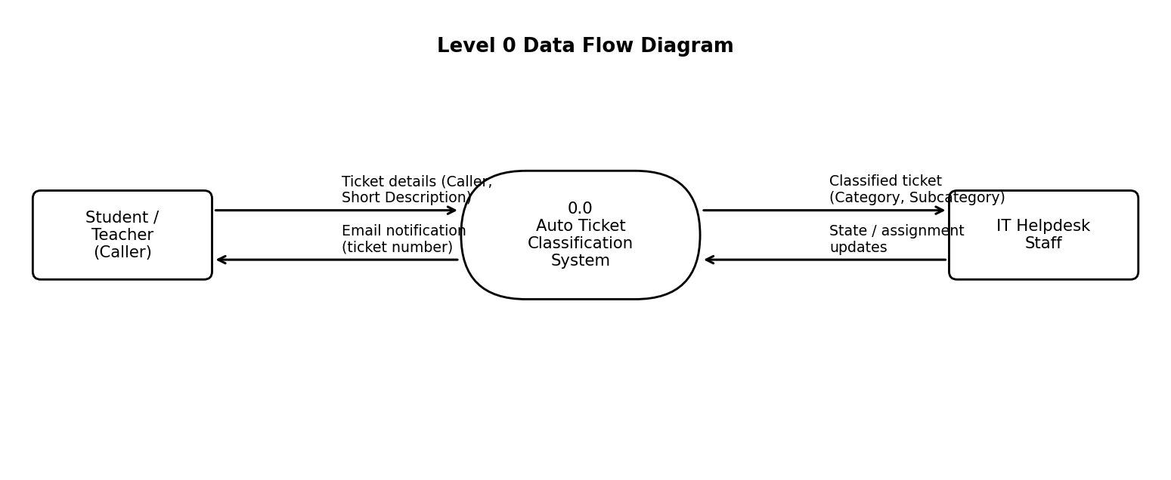
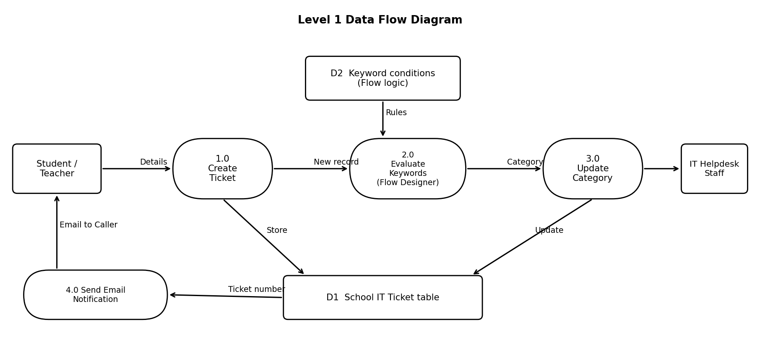
3.4 Technology Stack
S.No | Component | Technology
1 | User Interface | ServiceNow Form (School IT Ticket) designed with Form Designer
2 | Application Logic | Flow Designer: Created trigger, If / Else conditions, Update Record, Send Email
3 | Database | ServiceNow custom table School IT Ticket
4 | Choice Dependency | Dependent field configuration in the dictionary
5 | Configuration Management | Update Set (Project Update Set)
6 | Security | Access Control (ACL) and roles

4. PROJECT DESIGN
4.1 Problem Solution Fit
The problem is manual and inconsistent classification of school IT tickets. The solution fits the way callers already raise tickets: they describe the problem in a few words, and the same common keywords appear repeatedly. A flow that evaluates these keywords and updates the ticket removes the manual step without changing the caller’s behaviour.
4.2 Proposed Solution
A Flow Designer flow is triggered when a record is created in the School IT Ticket table. It evaluates the Short Description and Description and sets the Category and Subcategory according to the following rules.
Keyword in ticket text | Category | Subcategory
Wi-Fi / WiFi | Network | Wi-Fi
Projector | Hardware | Projector
Password / Login | Access | Forgot Password
Slow / Hanging | Performance | Slow Computer

If no keyword is found, the Else branch leaves Category and Subcategory empty so that IT staff can classify the ticket manually. After classification, an email is sent to the caller.
4.3 Solution Architecture
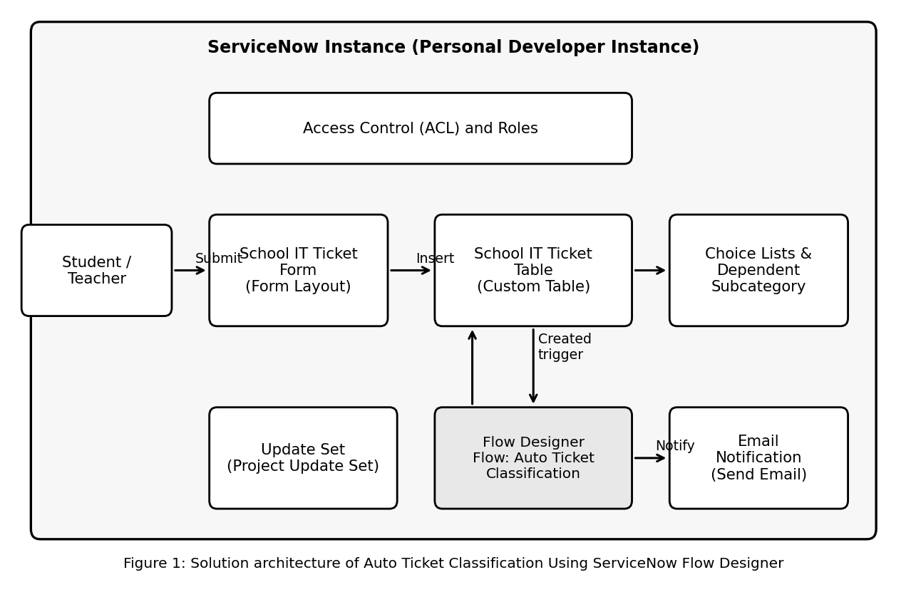
Flowchart of the classification flow
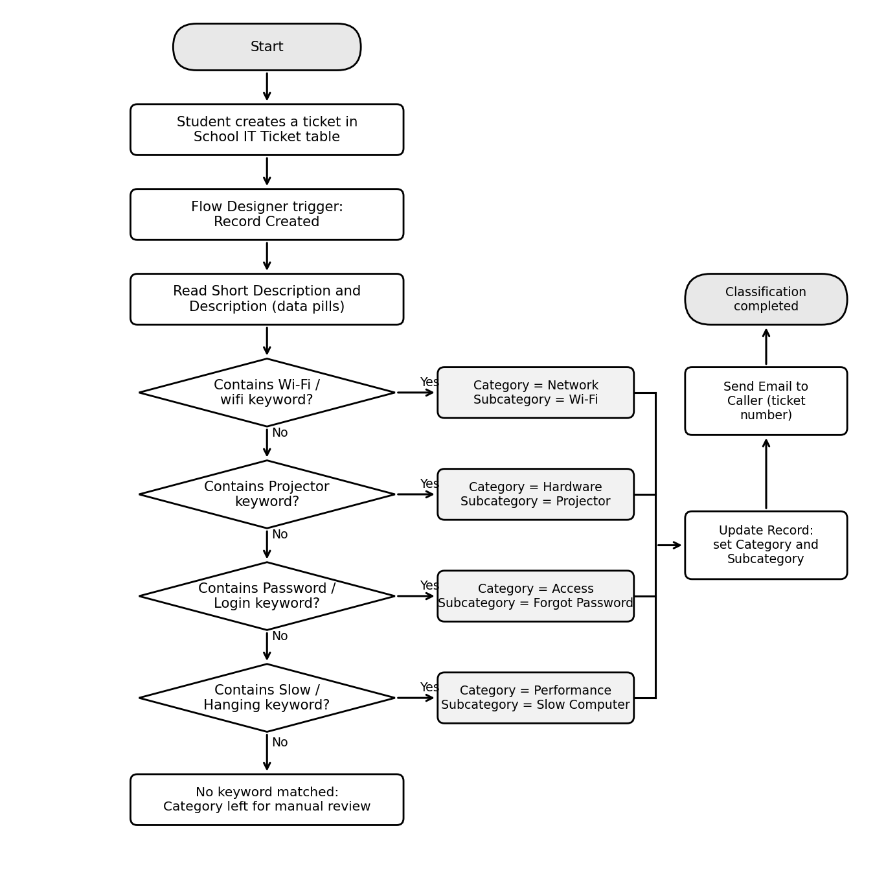
5. PROJECT PLANNING & SCHEDULING
5.1 Project Planning
The project was planned in four sprints of six days each, with 12 user stories and 40 story points in total. The velocity is 40 / 4 = 10 story points per sprint.
Sprint | Total Story Points | Duration | Start Date | End Date (Planned) | Points Completed | Release Date (Actual)
Sprint-1 | 10 | 6 Days | 07 Sep 2026 | 12 Sep 2026 | 10 | 12 Sep 2026
Sprint-2 | 10 | 6 Days | 14 Sep 2026 | 19 Sep 2026 | 10 | 19 Sep 2026
Sprint-3 | 10 | 6 Days | 21 Sep 2026 | 26 Sep 2026 | 10 | 26 Sep 2026
Sprint-4 | 10 | 6 Days | 28 Sep 2026 | 03 Oct 2026 | 10 | 03 Oct 2026

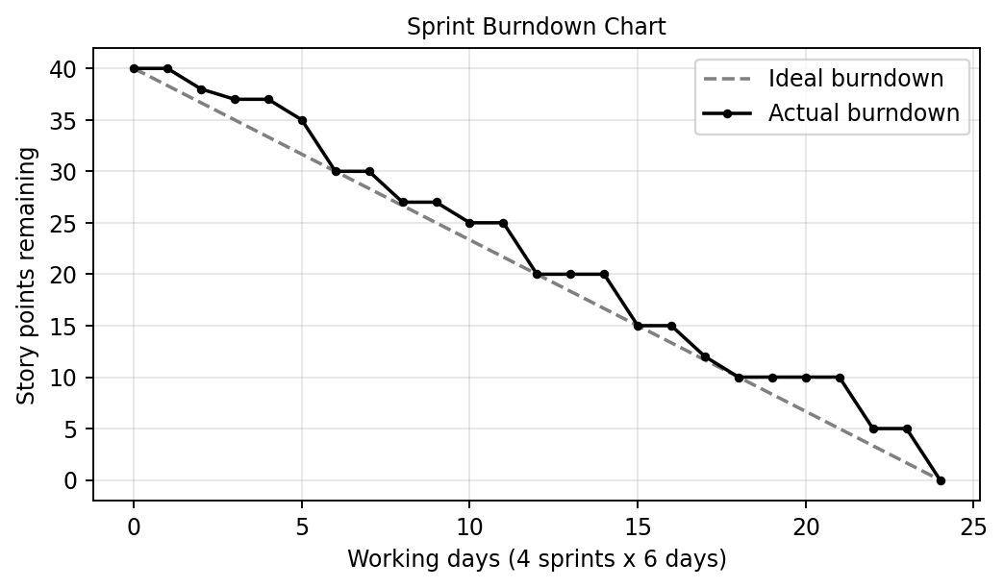
6. FUNCTIONAL AND PERFORMANCE TESTING
6.1 Performance Testing
Twenty test cases were executed. The table below lists the test cases, expected results and actual results.
Test Case | Scenario | Expected Result | Actual Result | Result
TC-01 | Create a ticket with Caller and Short Description | Ticket is saved with an auto-generated Number | Ticket saved with an auto-generated Number | Pass
TC-02 | Check the form layout | Number, Caller, Category, Subcategory, Short Description, Description, State, Assigned Group and Assigned to are displayed | All fields displayed on the form | Pass
TC-03 | Check default State of a new ticket | State shows the first choice value: New | State shown as New | Pass
TC-04 | Dependent choice: Category = Network | Only Wi-Fi is listed | Only Wi-Fi listed | Pass
TC-05 | Dependent choice: Category = Hardware | Only Projector is listed | Only Projector listed | Pass
TC-06 | Dependent choice: Category = Access | Only Forgot Password is listed | Only Forgot Password listed | Pass
TC-07 | Dependent choice: Category = Performance | Only Slow Computer is listed | Only Slow Computer listed | Pass
TC-08 | Short Description: “Wi-Fi is not connecting” | Category = Network; Subcategory = Wi-Fi | Category = Network; Subcategory = Wi-Fi | Pass
TC-09 | Short Description: “WiFi not working in the lab” | Category = Network; Subcategory = Wi-Fi | Category = Network; Subcategory = Wi-Fi | Pass
TC-10 | Short Description: “Projector is not displaying” | Category = Hardware; Subcategory = Projector | Category = Hardware; Subcategory = Projector | Pass
TC-11 | Short Description: “Forgot password” | Category = Access; Subcategory = Forgot Password | Category = Access; Subcategory = Forgot Password | Pass
TC-12 | Short Description: “Unable to login to account” | Category = Access; Subcategory = Forgot Password | Category = Access; Subcategory = Forgot Password | Pass
TC-13 | Short Description: “Computer is running very slowly” | Category = Performance; Subcategory = Slow Computer | Category = Performance; Subcategory = Slow Computer | Pass
TC-14 | Short Description: “System keeps hanging” | Category = Performance; Subcategory = Slow Computer | Category = Performance; Subcategory = Slow Computer | Pass
TC-15 | Negative test: “Printer paper jam” (no configured keyword) | Category and Subcategory remain empty for manual review | Category and Subcategory remained empty | Pass
TC-16 | Email notification on ticket creation | Email is sent to the Caller | Email sent to the Caller | Pass
TC-17 | Email content | Email refers to the ticket Number | Ticket Number present in the email | Pass
TC-18 | Access by an unauthorized user | Modification is not allowed | Modification blocked | Pass
TC-19 | Access by an authorized user | Update is saved | Update saved | Pass
TC-20 | Deletion by an unauthorized user | Deletion is not allowed | Deletion blocked | Pass

All 8 keyword classification test cases (including the negative case with no configured keyword) behaved as expected. The flow completed for each test ticket and the email notification was sent.
[INSERT FLOW EXECUTION SCREENSHOT HERE]

7. RESULTS
7.1 Output Screenshots
Results: tickets containing Wi-Fi, Projector, Password or Login, and Slow or Hanging were classified as Network / Wi-Fi, Hardware / Projector, Access / Forgot Password and Performance / Slow Computer respectively, without manual input. Tickets with no configured keyword were left for manual review.
[INSERT SERVICENOW TICKET FORM SCREENSHOT HERE]

[INSERT FLOW DESIGNER SCREENSHOT HERE]

[INSERT CLASSIFIED TICKET SCREENSHOT HERE]

[INSERT EMAIL NOTIFICATION SCREENSHOT HERE]

8. ADVANTAGES & DISADVANTAGES
Advantages | Disadvantages
Reduces manual effort in categorising tickets | Classifies only tickets that contain a configured keyword
Consistent classification for every ticket | Keyword spelling variants must be added to the conditions
Caller enters only Caller and Short Description | Printer and Software categories are not part of the current scope
Dependent choices keep Category and Subcategory data accurate | Does not assign tickets to support groups automatically
Email acknowledgement on ticket creation | Cannot understand the meaning of free text beyond keywords
No-code solution that is easy to maintain

9. CONCLUSION
The Auto Ticket Classification Using ServiceNow Flow Designer project delivers an end-to-end automation for a school IT helpdesk. Through requirement analysis, backend configuration and no-code automation, tickets are now classified automatically from the text entered by the caller, and the caller is notified by email. Dependent choice fields keep the data accurate, and testing and security validation confirmed that the system works as intended and that only authorized users can modify ticket data.
The project shows that ServiceNow Flow Designer can be used to build maintainable and user-friendly automation without scripting or machine learning. The design suits small and medium environments such as educational institutions.
10. FUTURE SCOPE
• Add more categories and keywords, such as Printer and Software.
• Assign tickets automatically to support groups.
• Add SLA tracking.
• Explore predictive classification as a later enhancement.
11. APPENDIX
Source Code (if any):
No custom script was written. The automation is built with Flow Designer and its configuration is summarised below.
Component | Configuration
Trigger | Created, School IT Ticket table
Conditions | Short Description / Description contains Wi-Fi or WiFi; Projector; Password or Login; Slow or Hanging
Actions | Update Record (Category, Subcategory); Send Email to the Caller
Else | Category and Subcategory left empty for manual review

Dataset Link:
Not applicable. The project does not use an external dataset.
GitHub & Project Demo Link:
GitHub: [INSERT GITHUB LINK HERE]
Project Demo: [INSERT PROJECT DEMO LINK HERE]

